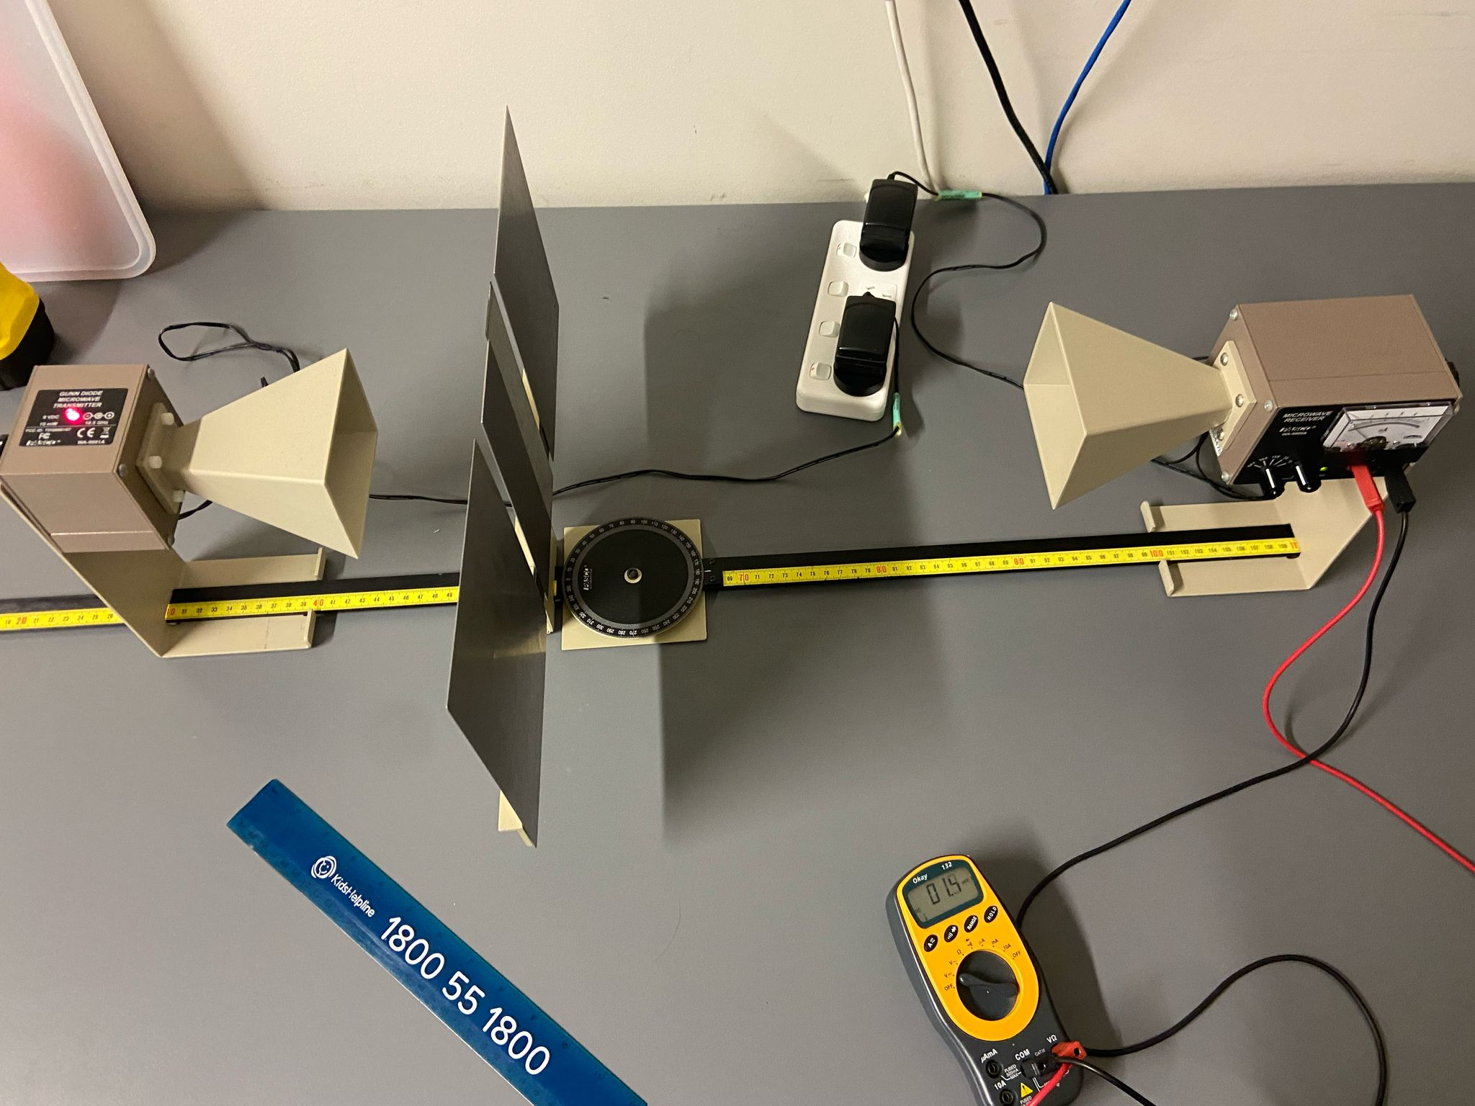

Tape measure track

30cm Ruler

Voltmeter

Double slit screen

Microwave receiver

Short axis protractor

Microwave transmitter